**Booking Management System**

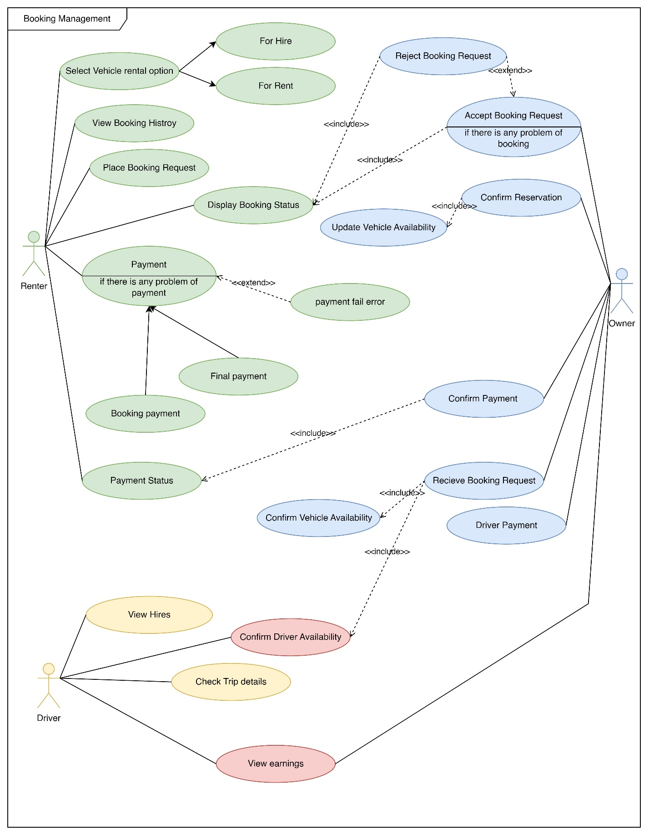

**Booking Management Use case Diagrams**

|  |  |  |
| --- | --- | --- |
| Name | Booking a vehicle for **hire** | |
| Summary | Renter books a vehicle for a hire | |
| Priority | 2 | |
| Preconditions | Renter must login to the system | |
| Postconditions | Renter can have reservation confirmation | |
| Primary Actor(s) | Renter , Vehicle Owner , Driver | |
| Main Scenario | **Step** | **Action** |
|  | 1 | Renter selects the booking type as hire |
|  | 2 | Renter filter and select a vehicle based on vehicle type and price ,etc. |
|  | 3 | Renter visits vehicle details page |
|  | 4 | Renter checks vehicle availability |
|  | 5 | Renter fills the request booking form with necessary information such as rental duration, pickup and return location, etc. |
|  | 6 | Renter clicks on request booking button |
|  | 7 | Vehicle owner confirms vehicle availability |
|  | 8 | Vehicle owner check driver availability |
|  | 9 | Vehicle owner accepts booking request |
|  | 10 | System notify renter with booking payment |
|  | 11 | Renter pays the booking payment |
|  | 12 | System shows booking successful msg to renter |
|  | 13 | System notifies vehicle owner about booking payment |
|  | 14 | Vehicle owner confirms booking payment |
|  | 15 | Vehicle owner reserve vehicle for renter |
|  | 16 | Vehicle owner updates vehicle availability |
|  | 17 | System generates full payment bill after trip |
|  | 18 | Renter pays full payment |
|  | 19 | Renter gives rating to vehicle and driver |
|  | 20 | Vehicle owner confirm payment received |
|  | 21 | Vehicle owner pays to driver |
|  | 22 | Driver confirms payment |
| Extensions | **Step** | **Action** |
|  | 7a | if the vehicle is not available, the system notifies the renter about the unavailability and suggests other available vehicles. |
|  | 8a | if the driver is not available, the vehicle owner attempts to assign another driver |
|  | 8b | If the vehicle owner fails to find an alternative driver, they inform the system about the vehicle’s unavailability. |
|  | 11a | if the payment fails, the system notifies the renter about the failed payment and asks them to try again or use a different payment method. |

**User Story : Booking a Vehicle for Hire**

As a Renter,

I want to log into the system,

So that I can book a vehicle for hire.

As a Renter,

I want to select the booking type as hire,

So that I can proceed with the booking process.

As a Renter,

I want to filter and select a vehicle based on vehicle type, price and location

So that I can choose the best vehicle for my needs.

As a Renter,

I want to check the vehicle's availability,

So that I can ensure the vehicle is available for hire.

As a Renter,

I want to fill out the request booking form with necessary information,

So that I can request a booking for the vehicle.

As a Vehicle Owner,

I want to confirm the vehicle's availability,

So that I can accept or reject the booking request.

As a Vehicle Owner,

I want to check the driver's availability,

So that I can ensure a driver is available for hire.

As a Vehicle Owner,

I want to accept the booking request,

So that I can reserve the vehicle for the renter.

As a Renter,

I want to pay the booking payment,

So that I can confirm my booking.

As a Renter,

I want to receive a booking successful message,

So that I know my booking has been successful.

As a Vehicle Owner,

I want to confirm the booking payment,

So that I can finalize the booking.

As a Vehicle Owner,

I want to update the vehicle's availability,

So that the system reflects the current availability of the vehicle.

As a Renter,

I want to pay the final payment after hire.

So that I can complete my payment

As a Vehicle Owner

I want to receive final payment.

So that I can return vehicle from renter

As a Vehicle Owner

I want to pay the driver.

So that driver can have the payment.

As a Driver

I want to confirm payment.

So that Owner can know to payment is successful.

As a Vehicle Owner

I want to change vehicle availability status.

So that other Renters can hire or rent the vehicle.

|  |  |  |
| --- | --- | --- |
| Name | Booking a vehicle for **rent** | |
| Summary | Renter books a vehicle for a rent | |
| Priority | 2 | |
| Preconditions | Renter must login to the system | |
| Postconditions | Renter can have reservation confirmation | |
| Primary Actor(s) | Renter, Vehicle Owner | |
| Main Scenario | **Step** | **Action** |
|  | 1 | Renter selects the booking type as rent |
|  | 2 | Renter filter and select a vehicle based on vehicle type and price,etc. |
|  | 3 | Renter visits vehicle details page |
|  | 4 | Renter checks vehicle availability |
|  | 5 | Renter fills the request booking form |
|  | 6 | Renter clicks on request booking button |
|  | 7 | Vehicle owner confirms vehicle availability |
|  | 8 | Vehicle owner accepts booking request |
|  | 9 | System notify renter with booking payment |
|  | 10 | Renter pays the booking payment |
|  | 11 | System shows booking successful msg to renter |
|  | 12 | System calculates amount of deposit and display to renter |
|  | 13 | System display required documents for reserve vehicle |
|  | 14 | System notifies vehicle owner about booking payment |
|  | 15 | Vehicle owners confirm booking payment |
|  | 16 | Renter pays the deposit and reserve vehicle |
|  | 17 | Vehicle owner updates vehicle availability |
|  | 18 | System Calculates Final Payment after renter returns vehicle back |
|  | 19 | System Reduces Final Payment from Deposit |
|  | 20 | Owner returns remaining deposit to renter |
| Extensions | **Step** | **Action** |
|  | 7a | if the vehicle is not available, the system notifies the renter about the unavailability and suggests other available vehicles. |
|  | 10a | if the payment fails, the system notifies the renter about the failed payment and asks them to try again or use a different payment method. |
|  | 13a | if the renter does not have the required documents for reserving the vehicle, the system informs the renter about the missing documents and asks them to provide them. |
|  | 18a | if the vehicle is returned with damage, the system adds a damage fee to the final payment. |
|  | 18b | if the vehicle is returned late, the system adds a late fee to the final payment. |

**User Story: Booking a Vehicle for rent**

As a Renter,

I want to log into the system,

So that I can book a vehicle for rent.

As a Renter,

I want to select the booking type as rent,

So that I can proceed with the booking process.

As a Renter,

I want to filter and select a vehicle based on vehicle type and price,

So that I can choose the best vehicle for my needs.

As a Renter,

I want to check the vehicle's availability,

So that I can ensure the vehicle is available for rent.

As a Renter,

I want to fill out the request booking form,

So that I can request a booking for the vehicle.

As a Vehicle Owner,

I want to confirm the vehicle's availability,

So that I can accept or reject the booking request.

As a Vehicle Owner,

I want to accept the booking request,

So that I can reserve the vehicle for the renter.

As a Renter,

I want to pay the booking payment,

So that I can confirm my booking.

As a Renter,

I want to receive a booking successful message,

So that I know my booking has been successful.

As a Vehicle Owner,

I want to confirm the booking payment,

So that I can finalize the booking.

As a Renter

I want to pay the full deposit for the vehicle

So that I can ren the vehicle without driver

As a Renter

I want to submit all required documentations

So that I can prove my self to vehicle owner.

As a vehicle owner

I want to confirm deposit and required documentations.

So that I can decide the renter can trusted or not

As a Vehicle Owner,

I want to update the vehicle's availability as booked.

So that other renters can’t book this vehicle until it available.

As a renter

I want to return vehicle after reserved time.

So that I can return deposit

As a Vehicle Owner

I want to calculate the cost and reduce it from deposit.

And return remaining deposit to renter.

As a vehicle Owner

I want to update vehicle availability,

So other renters can hire or rent this vehicle again.

**Functional Requirements:**

The system should allow the renter to log in.

The system should allow the renter to select the booking type (hire or rent).

The system should allow the renter to filter and select a vehicle based on vehicle type, price, etc.

The system should display vehicle details to the renter.

The system should allow the renter to check vehicle availability.

The system should allow the renter to fill a request booking form with necessary information.

The system should allow the vehicle owner to confirm vehicle availability.

The system should allow the vehicle owner to check driver availability (for hire).

The system should allow the vehicle owner to accept the booking request.

The system should notify the renter with booking payment details.

The system should allow the renter to pay the booking payment.

The system should show a booking successful message to the renter.

The system should notify the vehicle owner about the booking payment.

The system should allow the vehicle owner to confirm the booking payment.

The system should allow the vehicle owner to reserve the vehicle for the renter.

The system should allow the vehicle owner to update vehicle availability.

**Non-Functional Requirements:**

The system should be user-friendly, with an intuitive interface for both renters and vehicle owners and drivers.

Security, usability, performance, reliability, scalability, compatibility

The system should be able to send notifications in real-time.

The system should be available 24/7 with minimal downtime.

The system should ensure the privacy and security of user data.

The system should be easy to use and navigate for all types of users, vehicle renters and vehicle owners.

**Technical Requirements:**

The system should be web-based, accessible via any modern web browser.

The system should be built using a reliable and scalable tech stack.

The system should use a secure database for storing user data.

The system should be hosted on a secure and reliable web server.